UNITED STATES

SECURITIES AND EXCHANGE COMMISSION
Washington, D.C. 20549
FORM 6-K
REPORT OF FOREIGN PRIVATE ISSUER PURSUANT TO RULE 13a-16 OR
15d-16 UNDER THE SECURITIES EXCHANGE ACT OF 1934
For the month of October, 2026
Commission File Number: 1-13546
STMicroelectronics N.V.
___________________________________________________________________________________________
(Name of Registrant)
WTC Schiphol Airport
Schiphol Boulevard 265
1118 BH Schiphol Airport
The Netherlands
___________________________________________________________________________________________
(Address of Principal Executive Offices)
Form 20-F Q Form 40-F ☐
Indicate by check mark whether the registrant files or will file annual reports under cover of Form 20-F or

Form 40-F:
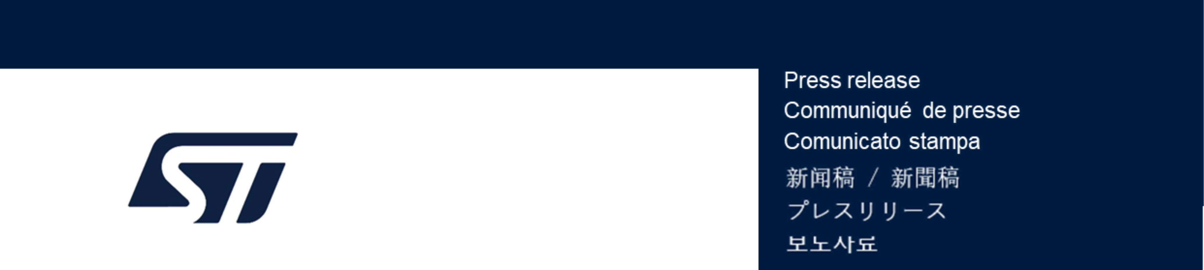
Enclosure: A press release dated October 13, 2026, announcing STMicroelectronics to propose the

reappointment of Jean-Marc Chery as President & CEO.

PR N°C3416C
STMicroelectronics to propose the reappointment of
Jean-Marc Chery as President & CEO
About STMicroelectronics

discipline and the momentum achieved under Mr. Chery’s leadership.

The decision recognizes the importance of the continuity of ST’s strategy, execution

and its stakeholders.

ST’s value proposition, and a strong foundation for long-term value creation for ST

provided ST with a clear strategic course supporting the continued development of

Mr. Chery’s leadership and vision, combined with a strong focus on execution, have

Company's President and Chief Executive Officer.
Geneva, October 13, 2026
one-year term of Jean-Marc Chery, as Chairman of the Managing Board and the

Company's 2027 Annual General Meeting of Shareholders, the reappointment for a

The Supervisory Board will therefore propose to the shareholders adoption at the

Chery has accepted the proposal.

be available for a reappointment in his current role for an additional year. Jean-Marc

that its Supervisory Board has asked Jean-Marc Chery, ST’s President and CEO, to

– STMicroelectronics (NYSE: STM) announced today
At ST, we are 49,000 creators and makers of semiconductor technologies mastering
the semiconductor supply chain with state-of-the-art manufacturing facilities. An
integrated device manufacturer, we work with more than 200,000 customers and
thousands of partners to design and build products, solutions, and ecosystems that
address their challenges and opportunities, and the need to support a more
sustainable world. Our technologies enable smarter mobility, more efficient power
and energy management, and the wide-scale deployment of cloud-connected
autonomous things. We are on track to be carbon neutral in all direct and indirect
emissions (scopes 1 and 2), product transportation, business travel, and employee
commuting emissions (our scope 3 focus), and to achieve our 100% renewable
electricity sourcing goal by the end of 2027. Further information can be found at
www.st.com
For more information, please contact:
INVESTOR RELATIONS
Jérôme Ramel
EVP Corporate Development & Integrated External Communication
Tel: +41.22.929.59.20
jerome.ramel@st.com

MEDIA RELATIONS
Alexis Breton
Group VP Corporate External Communications
Tel: +33.6.59.16.79.08
alexis.breton@st.com
SIGNATURES
Pursuant to the requirements of the Securities Exchange Act of 1934, the registrant has duly caused this report to

be signed on its behalf by the undersigned, thereunto duly authorized.
Date:

STMicroelectronics N.V.

