UNITED STATES

SECURITIES AND EXCHANGE COMMISSION
Washington, D.C. 20549
FORM 6-K
REPORT OF FOREIGN PRIVATE ISSUER PURSUANT TO RULE 13a-16 OR
15d-16 UNDER THE SECURITIES EXCHANGE ACT OF 1934
For the month of October, 2026
Commission File Number: 1-13546
STMicroelectronics N.V.
___________________________________________________________________________________________
(Name of Registrant)
WTC Schiphol Airport
Schiphol Boulevard 265
1118 BH Schiphol Airport
The Netherlands
___________________________________________________________________________________________
(Address of Principal Executive Offices)
Form 20-F Q Form 40-F ☐
Indicate by check mark whether the registrant files or will file annual reports under cover of Form 20-F or

Form 40-F:
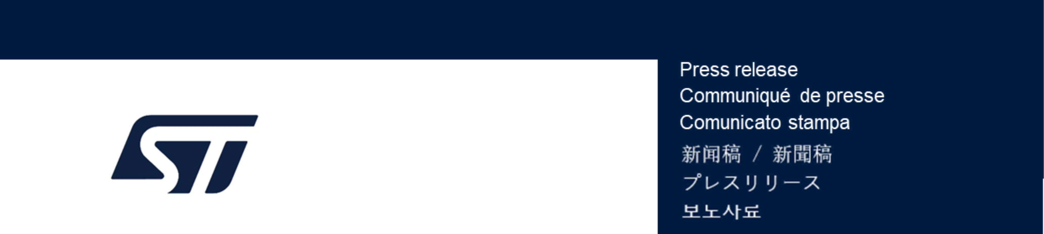
Enclosure: A press release dated October 12, 2026, announcing the results of trading in STMicroelectronics'

own shares as part of the previously announced share buy-back program for the period from October 5, 2026

to October 9, 2026.

STMicroelectronics announces status
PR N°C3415C
of common share repurchase program
Disclosure of Transactions in Own Shares – Period from October 5, 2026 to October 9, 2026
In accordance with Article 5(1)(b) of the Market Abuse Regulation and Article 2(3) of

(the Market Abuse Regulation) was to meet obligations arising from share option

programmes, or other allocations of shares, to employees or to members of the

administrative, management or supervisory bodies of the issuer or of an associate

company.
The shares may be held in treasury prior to being used for such purpose and, to the

extent that they are not ultimately needed for such purpose, they may be used for

any other lawful purpose under article 5(2) of the Market Abuse Regulation.
The purpose of these transactions under article 5(2) of Regulation (EU) 596/2014
Below is a summary of the repurchase transactions made in the course of the Period

in relation to the ordinary shares of STMicroelectronics (ISIN: NL0000226223), in

detailed form.
Transactions in Period
5-Oct-26
6-Oct-26
7-Oct-26
8-Oct-26
9-Oct-26
Total for Period

Following the share buybacks detailed above, the Company holds in total 15,930,103

treasury shares, which represents approximately 1.7% of the Company’s issued

share capital.
STMicroelectronics N.V. (registered with the trade register under number 33194537)

-- STMicroelectronics N.V. (the “Company” or

“STMicroelectronics”), a global semiconductor leader serving customers across the

spectrum of electronics applications, announces full details of its common share

repurchase program (the “Program”) disclosed via a press release dated June 21,

2024. The Program was approved by a shareholder resolution dated May 22, 2024

and by the supervisory board.
AMSTERDAM – October 12, 2026

(LEI: 213800Z8NOHIKRI42W10) announces the repurchase (by a broker acting for

the Company) on the regulated market of Euronext Paris, in the period between

October 05, 2026 to October 09, 2026 (the “Period”), of 346,538 ordinary shares

(equal to 0.04% of its issued share capital) at the weighted average purchase price

per share of EUR 49.2425 and for an overall price of EUR

17,064,401.16.
Dates of
transaction
Number of
shares
purchased
Weighted
average
purchase price
per share
(EUR)
Total amount
paid (EUR)
Market on
which the
shares were
bought (MIC
code)
Commission Delegated Regulation (EU) 2016/1052, a full breakdown of the
individual trades in the Program are disclosed on the ST website (https://
investors.st.com/stock-and-bond-information/share-buyback).
About STMicroelectronics
At ST, we are 49,000 creators and makers of semiconductor technologies mastering
the semiconductor supply chain with state-of-the-art manufacturing facilities. An
integrated device manufacturer, we work with more than 200,000 customers and
thousands of partners to design and build products, solutions, and ecosystems that
address their challenges and opportunities, and the need to support a more
sustainable world. Our technologies enable smarter mobility, more efficient power
and energy management, and the wide-scale deployment of cloud-connected
autonomous things. We are on track to be carbon neutral in all direct and indirect
emissions (scopes 1 and 2), product transportation, business travel, and employee
commuting emissions (our scope 3 focus), and to achieve our 100% renewable
electricity sourcing goal by the end of 2027. Further information can be found at
www.st.com
For more information, please contact:
INVESTOR RELATIONS
Jérôme Ramel
EVP Corporate Development & Integrated External Communication
Tel: +41.22.929.59.20
jerome.ramel@st.com

MEDIA RELATIONS
Alexis Breton
Group VP Corporate External Communications
Tel: +33.6.59.16.79.08
alexis.breton@st.com
SIGNATURES
Pursuant to the requirements of the Securities Exchange Act of 1934, the registrant has duly caused this report to

be signed on its behalf by the undersigned, thereunto duly authorized.
Date:

STMicroelectronics N.V.

